Please read all instructions carefully before beginning. This is a semantic segmentation task used for medical analysis. The dataset contains images similar to x-rays in which the femur (thighbone) is at least partially visible in a circular view with a black background (referred to as “black window” in examples). Your task is to outline the area that contains the femur bone in each image.

* Be especially careful to correctly outline the femur head (“ball”). A common mistake is to include the “socket” surrounding the femur head where the femur connects to the rest of the pelvis. The segmentation of the femur head should be approximately circular (except when the black window obscures part of the femur head).
* Ignore any obstructions from tools, surgical wires, and shadows when determining the outline of the bone. Sometimes, it is necessary to estimate where the bone is behind a large obstruction.
* Never include parts of the black background outside of the circular view, even when estimating near an obstruction.

A cartoon of a pelvis is shown below. The circled region is approximately the area shown in the real images.

All images in the dataset show the femur from a front (“anterior”) or back (“posterior”) view. The diagram above shows an anterior view. Below is a diagram showing a more detailed anatomy of the femur in anterior and posterior views.

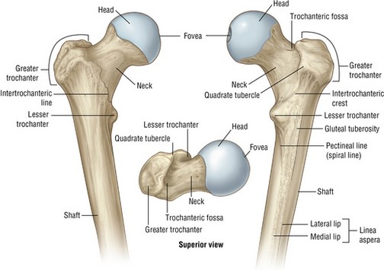

**Examples**

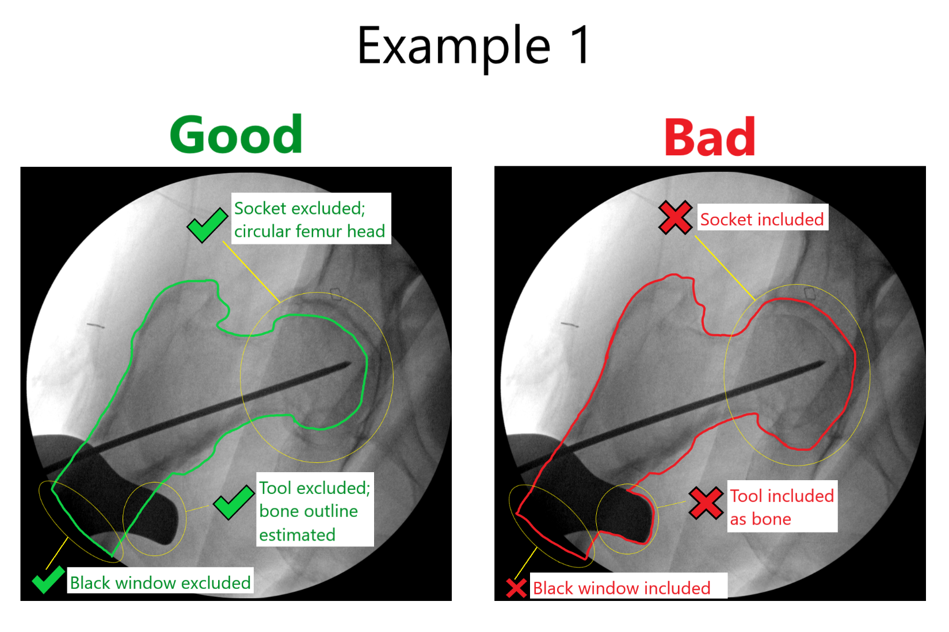

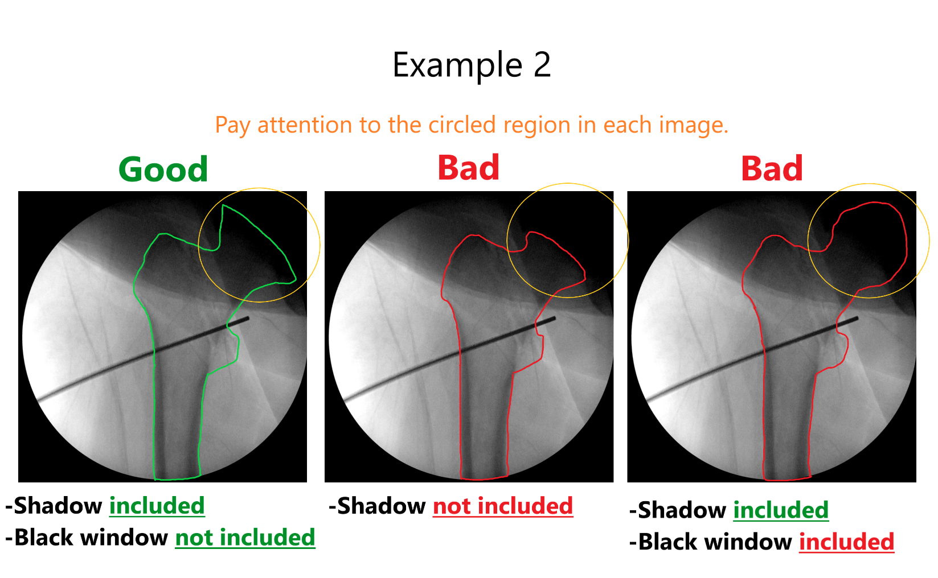

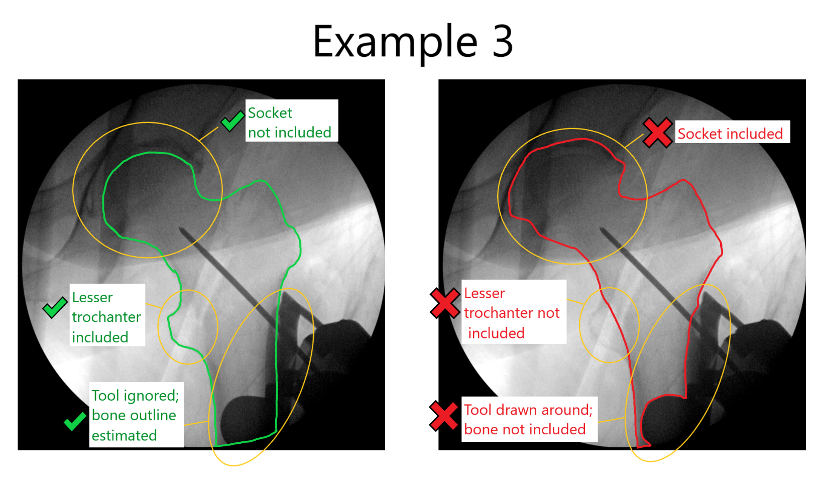

**Note: Segmentation submissions are graded. Good performers may be invited back to do more images.**